Artificial Joints

Design of Medical devices and Implants

By Joel Sandé

**Abstract**

Artificial joints are very important in the society, noting that almost all problems related to bones are often linked to reattaching them. Generally, it exist a distinction between in one hand the ligament, and in the other the tendon as for existing natural joints. Clinical methods of ligament’s substitution are autografts and allografts, but the tissue engineering is still trying to find more effective ways to integrate polymers such as Chitosan, Silk without its toxin, Polyethylene terephthalate or even Polyhydroxyester. Pure Titanium is fortunately one of the materials that have already proved his efficiency and resistibility inside some patients’ body. Given that the roles of joints are different, the goal of this project is to propose methods for design and modifications of joints based on specific case problems. The expected results are positive for the majority, revolutionary for some, and for those taking into account the affect of cell signaling, which remains poorly documented to, results are uncertain.

**Project report**

The objective of this project is to use existing knowledge in Biology and Materials Engineering to synthesize artificial joints and then propose methods for design and modifications based on specific case problems.

- The data collected in Biology will provide information on existing natural, biological function, structure, organization, tissue, responsible cells and molecules involved in joints as well as their correlations with the bones and muscles.

- Engineering data will provide information on other mimesis molecular options and manufacturing techniques in the laboratory up to this day.

This work will propose something satisfying, feasible in terms of engineering, compatible with natural bone as well as muscles, to ensure that the resulting results are the best. For the joint to be useful, it has to be fixing on natural bone, nothing that bone and joint are complementary to each other, the bone is useless without the joint and the joint is useless without the bone.

Problems that may arise in the project are essentially based on the difference between connecting joints and bones together, between connecting the bones and the muscles, and the structure method attachment between them.

**Hypothesis**

First of all, it is more likely that joints linking bones together are much thicker than those linking muscles to bones. Also, as the bone is the most rigid tissue in the body, it is potentially more likely accept a non-biological material, such as heavy metal, in comparison with any other body tissue.

Giving answers to those hypotheses will guide us to conduct a biocompatible model on natural bone, which is as efficient as the natural joint.

**Rationale**

The bone system is one of the most important systems of the vertebrate. It is the crucial support of the mammal being. It plays three essential roles that are: maintaining general physical balance; protecting organs; and movements’ execution, including object manipulation. The bone is highly complementary to natural joints called cartilage or tendons in the sense that without the joint that connects bones together, or that connects bones to muscles, the mammal can’t do fluid movements, control its bone system from the muscle, or regain stability in the case of a fracture. In other words the bone cannot move by itself.

The design of natural joints will solve many problems in the society: bone fixation due to torn tendons, bone replacement due to dislocation to the cavity, bone grafting following a fracture. In general, resolving bones’ problems involve fixation issues. For example, intensive sports or traffic accidents are two common situations where we face bone problems.

The issue of joints is enormous for both those who are concerned namely people, but also for the welfare State budget. Artificial joint is the solution for an individual to whom it was told after an accident that he will never walk again. This situation will hamper him the rest of his life and makes him dependent on all the support the welfare state could offer without having him in the labor force. The invention of artificial ligament could be very beneficial for people suffering from arthritis pain if we can make models of cartilage adaptable to fingers.

It is estimated that more than 15% of the world population are affected by osteoarthritis, which is one disease that may alter joint and lead a patient to a total joint replacement (Egloff et al, 2012). Also, some problems such as the risks of disease transmission, lacks of donors, and donor recipient incompatibility have imposed additional restrictions on the already limited amount of human transplants (Novakovic et al, 2004). The Anterior Cruciate Ligament (ACL) that serves as a primary stabilizer of the knee motion is susceptible to rupture or tear, a situation which can cause pain and discomfort, joint instability, and eventually degenerative joint diseases. An estimated of 200,000 Americans required reconstructive surgery of ligaments in 2002 with a price tag exceeding five billion dollars (Novakovic et al, 2004). Based on this literature review, we can state that artificial joints are very important.

**State of the Art**

Structure and composition of natural bone

"The man built his materials under extreme conditions of temperature and pressure, in contrast with biological materials that are done under ambient conditions, from simple elements and incredibly durable due to their structure and interaction at all levels as well as to microscopic scale, and macroscopic" (Beniash Elia, 2011). Before proposing a joint artificial, it is necessary to understand the joint structure and natural functionality. There are two types of natural joints: the first joint named the ligament which connects one bone to another, and the second one named the tendon that connects bones to muscles (Yilgor et al, 2012). We have to return back to the structure of the bone to fully understand the structure of both the cartilage and the tendon.

Bone refers to a family of materials constructed from small blocks of mineralized collagen fiber having several levels of organization (Weiner and Wagner, 1998). It is produced by specialized cells called osteoblasts, bone matrix consists of collagen, carbonate apatite crystals and proteins called non-collagenous, and regulatory crystallization.

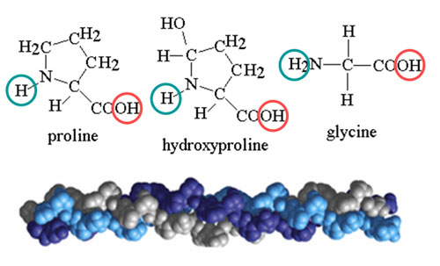

**Figure 1:** Collagen triple helix.

Highlighting of the amino acids constituting the collagen. Proline, hydroxproline en glycine which principally are hydrophobes (chemistryland.com).

They produce the collagen fibers and macromolecules, which mineralize non-collagenous micrometers away from them (Beniash Elia, 2011) (Shapiro, 2008). Released into the extracellular medium, pro-collagens contain two end blocked that prevent them from self-assemble within the cell (Khoshnoodi, 2006). Once the cleavage is done, tropocollagens long to 300 nm and 1.5 nm as diameter, self-assemble in the form of fiber by spacing at 67 nm (Beniash Elia, 2011). Measured by TEM, each fiber is a long triple helix polypeptide of about 1,000 amino acids (Weiner and Wagner, 1998), mainly a repeat of Gly-Pro-Hyp (Beniash Elia, 2011).

Far from being homogeneous, the biochemical composition of the bone tissue varies all along from the cell to the mineral layer (Beniash Elia, 2011). The fibers’ alignment in one direction or another optimizes mechanical function, so that the particular alignment of fibers end bone gives them a certain elasticity to facilitate the attachment of tendons to their surface (Weiner and Wagner, 1998) (Shapiro, 2008).

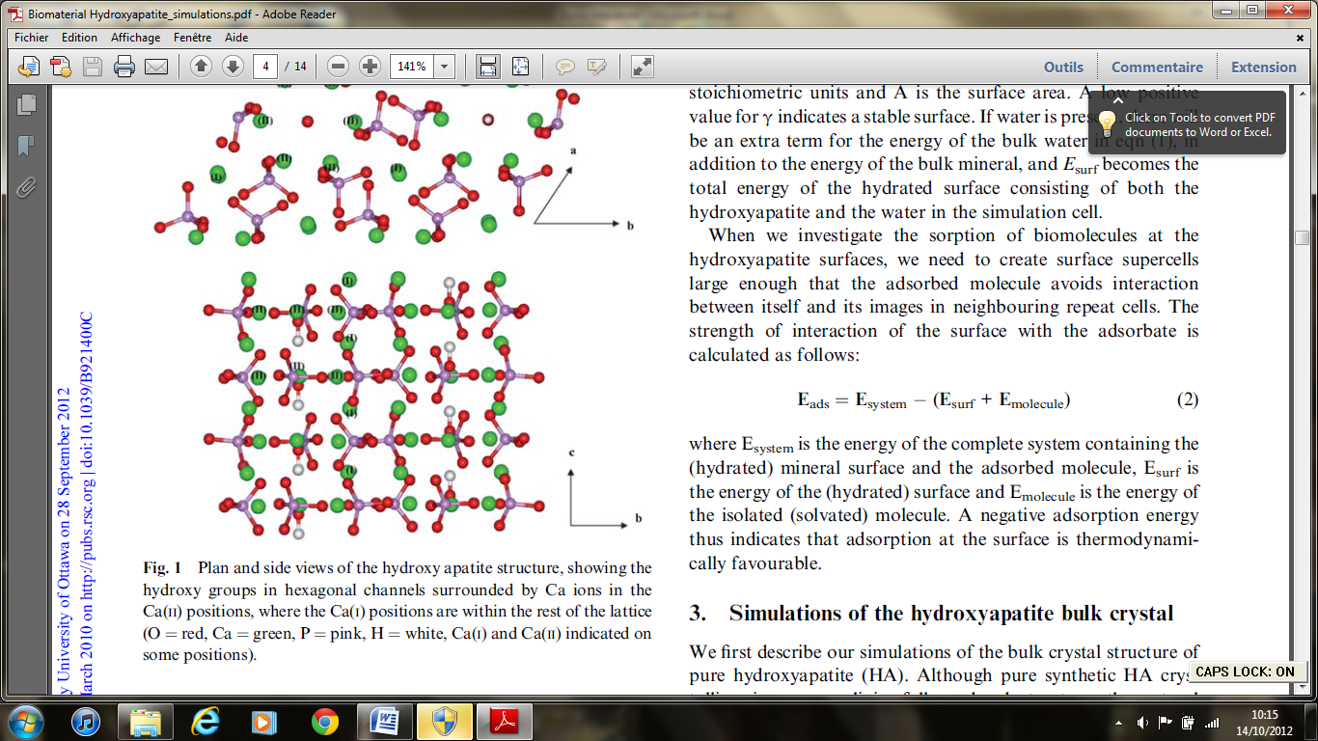

**Figure 2:** Hydroyapatite structure.

In purple, phosphate atoms; in red, oxygen atoms; in green, calcium atoms and white hydrogen. The structure built from Phosphate (PO4) tetrahedral around which are regularly positioned calcium ions Ca2+. (Leeuw, 2010).

Collagen is the matrix from which bone mineral are formed (Weiner and Wagner, 1998) (Shapiro, 2008). This mineral is the Dahllite that is called Crystal Carbonate Apatite, Hydroxyapatite or Calcium phosphate formula Ca5 (PO4 CO3) 3OH (Weiner and Wagner, 1998) and often described as Ca10 (PO4)6 (OH)2 (Venkatesan and Kim, 2010).

There is a hexagonal structure built from Phosphate (PO4) tetrahedral around which are regularly positioned calcium ions Ca2+ (Leeuw, 2010) (Fig 2). Although the collagen fibers are the main elements, they cannot cause mineralization of calcium phosphate (Beniash Elia, 2011). This role is attributed to non-collagenous proteins belonging to the family of the SIBLING (Small Integrin Binding Ligand N-linked Glycoprotein) (Beniash Elia, 2011). Approximately 200 other proteins called non-collagenous (NCPs) constituting 10% of all quantitative total protein (Weiner and Wagner, 1998).

According to Young's modulus, the more the bone is rich in minerals located in the crystal such as calcium, the more it became compact, robust, and less porous (Weiner and Wagner, 1998). Crystals grown up, solidified the structure by approaching one to the other, and formed sheets (Weiner and Wagner, 1998).

Structure of tendon and ligament in the natural state

Tendon

Microfibrils aggregate in an approximately triclinic lattice to form fibrils (0.5 mm in diameter); fibrils aggregate to form fibers (3–7 mm in diameter); fibers aggregate to form fascicles (150–300 mm in diameter); and fascicles combine to form tendon (millimeters in diameter) (Genin et al, 2009).

To be done, the tendon-to-bone insertion connects two vastly different and highly ordered hierarchical tissues across a millimeter-wide region. Tensile modulus of tendon is about 0.4 GPa in the direction of muscle force during physiologic loading conditions, and about 20 GPa for bone (Genin et al, 2009).

Also, the examination of the tendon-to-bone insertion shows two factors that give the tendon-to-bone transition a unique grading in mechanical properties. Those factors are a gradation in mineral (carbonated apatite mineral) concentration, and a gradation in collagen fiber orientation. This gradient of the tendon-to-bone insertion involves four discrete zones (Genin et al, 2009). Also, tendons’ fibers have a unique structural organization that is much simpler than the majority of bones (Elia Beniash, 2011).

Ligament

Ligaments are dense fibrous connective tissues that connect one bone to the other. Their dry weight consists of collagen (75%), elastin (1%), proteoglycans, and glycoproteins (Yilgor et al, 2012). As we highlighted in tendons, ligament-bone interface consists of four distincts but continuous regions: ligament, noncalcified fibrocartilage, calcified fibrocartilage, and bone. In case of an injury, the native interface is not regenerated. In this manner, to recreat this multi-zone organization, it is important to have a stratified or multi-phased scaffold that exhibits a continuing increase in mechanical properties through the scaffold phases. Moreover, multiphased or 3D braided scaffolds, stem cell applications, cytokines, BMP-2, and BMP-12 are also taking into account in order to improve regeneration of this interface. Coating of tendons with calcium phosphate layer, TGF-*β*, and BMP-2 help to improve osteointegration between ACL and bone tunnel. (Yilgor et al, 2012).

Existing clinical strategies

In general, clinical approaches in ligament repair and regeneration are limited to autografts, as for gold standard, and allografts with their high mechanical strength and compatibility (Novakovic et al, 2004). The grafts work well with addition of polylactic acid (Nagarkatti et al, 2001). Allografts exclude the risks associated with autografts, such as donor site morbidity. However, they carry additional risks of disease transmission, infection, and allergic reactions in addition to their lower early cellularity and less revascularization (Yilgor et al, 2012).

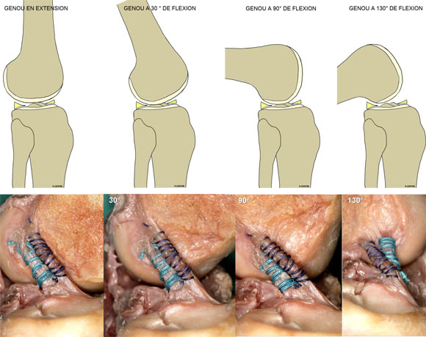

**Figure 3:** Ligament transplant. Allografts at the knee performed in clinical (genouetsport.fr).

Both of these techniques have their own drawbacks that limit them to succeed in clinical setting. Tissue engineering is a novel promising technique that aims to solve these problems, by producing viable artificial ligament substitutes in the laboratory, (Yilgor et al, 2012).

Biological hormones contribution

Growth factors are regulators of cellular activities and several of them, including insulin like growth factor I (IGF-I), transforming growth factor-*β* (TGF-*β*), vascular endothelial growth factor (VEGF), basic fibroblast growth factor (bFGF), epidermal growth factor (EGF), and platelet derived growth factor (PDGF), are effective in the healing of ligament repair (Yilgor et al, 2012).

Cell sources used to repair ligaments include MSCs, which has revealed great potential in tissue engineering as a cell source that can differentiate into various connective tissue cell types including fibroblasts (Yilgor et al, 2012). Collagen hydrogels are used to increase both ACL healing in a bovine model, and cell accumulation reported with TGF-*β*1-transferred hydrogels (Yilgor et al, 2012).

Strategies for engineering, engineering tissue, engineering materials.

From the clinical point of view, the main advantage offered by the use of tissue engineered ligament could listed to be minimal patient morbidity, simpler surgical technique, reliable fixation methods, rapid return to pre-injury functions, immediate functionality, minimal risk for infection or disease transmission, biodegradation that provides adequate mechanical stability, and supporting host tissue in growth (Yilgor et al, 2012), (Novakovic et al, 2004), (Gomes et al, 2008). The high incidence of ACL failures is the lack of capacity for self-repair, and limitations of current treatment options that make the research on ligament tissue engineering to be a new option (Novakovic et al, 2004).

As we can see in Fig 4, the design (i.e., a four zone attachment) is fundamentally different from engineering design strategies for attachment of two dissimilar engineering materials. Engineers make an abrupt transition between tendons and bone (Genin et al, 2009). They use metallic devices for orthopaedic applications with hundreds of thousands being implanted annually. This is because pure titanium is known to be an excellent osseo-integrator, (Plecko et al, 2012).

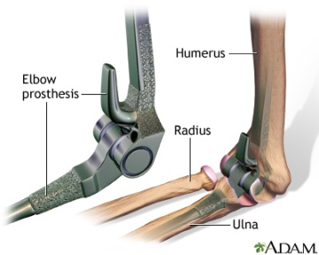 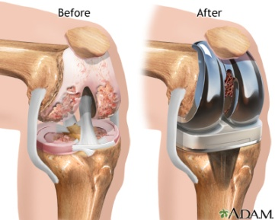

**Figure 4:** Gold standard of artificiel ligament. Artificial Ligament made with pure Titanium adam.com

But these implantations techniques on Fig 4 do not solve the problem of non-articular fracture Fig 6. This is a bone fracture that requires a joint natural bone. The bone paste solidifies is required in this case.

Chitosan (3D porous), Chitosan / polyester (3D porous), Chitosan / GP (injectable gel), Chitosan / HA (osteochondral), Dacron, Gore-Tex, Leeds-Keio polyester, polypropylene-based Kennedy Ligament Augmentation Device are used for the synthesis of cartilage, while chitosan / hyaluronic acid (HA) is used for the synthesis of tendon. Some of them failed to solve problems for many reasons such as the lake of tissue ingrowth or foreign body response (Gomes et al, 2008), (Novakovic et al, 2004).

Silk is also used as a ligament replacement material. The reason is that because it has a relatively slow rate of degradation within the body compared to collagen and other natural biomaterials used in this case, which could possess an advantage in load-bearing applications (Yilgor et al, 2012), (Novakovic, 2004).

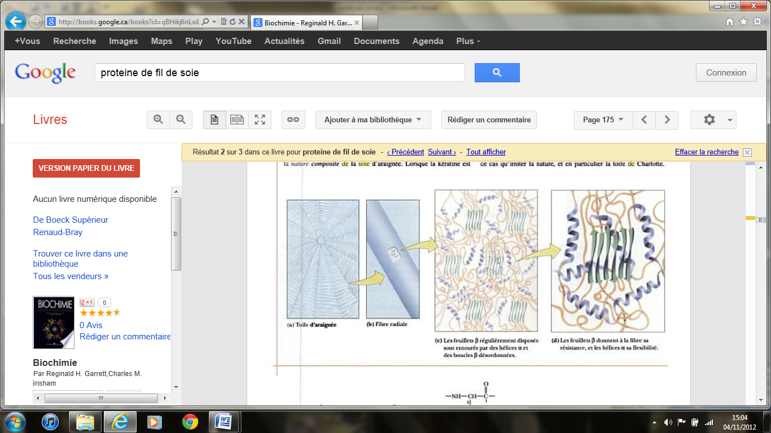

**Figure 5:** Proteins of Silk.

Silk is mainly composed of glycine (42%), alanine (25%) and exists β sheets that give strength, surrounded by α helix that give flexibility (Johnson, 2002) (Garrett and Grisham, 2000).

The use of pure silk includes problems associated with the sericin protein because it may lead to allergic reactions (Yilgor et al, 2012). This issue was overcome by the use of virgin silk in which this allergen was extracted. Silk fibroin is a protein excreted by silkworms and isolated from sericin. It can be fabricated into gels, films, and fibers. With regard to animals, it has been reported to regenerate ligaments, thus claimed to be an excellent natural biomaterial alternative to collagen (Yilgor et al, 2012). It can be degraded by protease and chymotrypsin. Importantly, for silk to degrade, proteolytic attack that typically coincides with the onset of angiogenesis is needed. Overall, it’s a slowly degrading biomaterial with biocompatibility comparable to that of most materials in clinical use (Novakovic, 2004). It undergoes proteolytic degradation at a rate that depends on the environmental conditions. Its fibers lose their tensile strength within one year in vivo and degrade completely within two years (Novakovic, 2004). It scaffolds also support cell attachment and spreading by providing an appropriate 3-D culture environment.

ECM bioscaffolds such as small intestine submucosa (SIS) and urinary bladder matrix (UBM) are composed of collagen and contain cytokines and growth factors. SIS were found to support ligament and tendon regeneration, and claimed to be effective candidate tools for ligament tissue engineering in different animal models (Badylak, 2004), (Yilgor et al, 2012), (Liang et al, 2012). It has been widely implemented because of its natural topography and the various growth factors it contains, such as FGF, TGF-b, VEGF, PDGF-BB and IGF [9–12], which can promote cell proliferation, matrix production and angiogenesis. In addition, it is biodegradable and can be replaced by healing tissues over time.

The extracellular matrix is a collection of structural and functional molecules that are organized in a three dimensional ultrastructure and that are unique for each tissue and organ (Badylak, 2004). Factors that contribute to change in ECM composition and structure include environmental forces such as mechanical loading, oxygen tension, specific growth factor, and pH. Within a short time, the resident cells respond to environmental cues and secrete appropriate molecules accommodate new and changing environments, thus modifying the existing ECM (Novakovic, 2004). Ascorbate-2-phosphate, a long-acting derivative of vitamin C, enhanced cell growth in vitro and supported the maintenance of connective tissues. Growth factors, such as epidermal growth factor (EGF), basic fibroblast growth factor (bFGF), insulin-like growth factor-II (IGF-II), and transforming growth factor-beta (TGF-*β*) have the capacity to increase cell proliferation (Novakovic, 2004).

Polyethylene terephthalate has already been tested as artificial ligament. The results were 69% of rupture, which are justified by the clinical condition of the lacing and the performance of instruments rather instead of the quality of the polymer itself (Struewer et al, 2012).

Polyhydroxyesters or poly(alpha-hydroxy-esters) that degrade by hydrolysis are biodegradable polymers that are popularly used in ligament repair. Braided PLGA scaffolds were claimed to have great promise for ligament engineering (Yilgor et al, 2012) ([WJ](http://www.ncbi.nlm.nih.gov/pubmed?term=Li%20WJ%5BAuthor%5D&cauthor=true&cauthor_uid=16765878) et al, 2006).

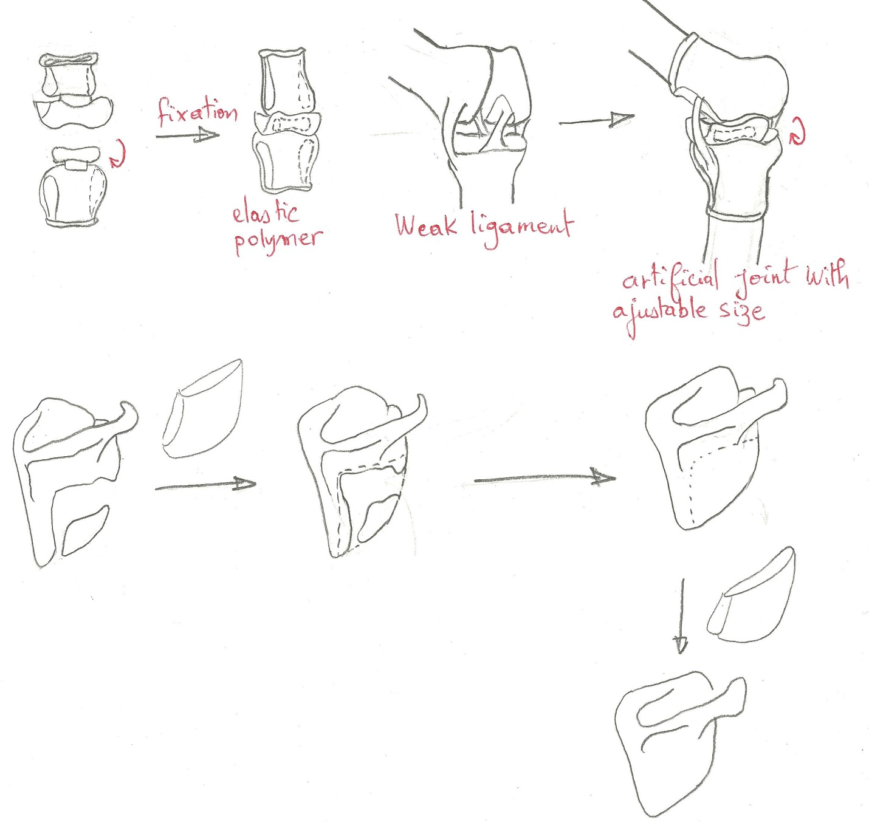

**Figure 6:** Rupture unrelated to a ligament. It’s a big gap at the flat bone of the shoulder blade. No joint known to date can fix this problem.

The bone paste is solidifying nanostructured hydroxyapatite (NHA) pasty which solidifies on contact with air without returning to its initial state (Kasaj et al, 2008). What is remarkable is that the dough is conducive to cell proliferation, especially periodontal ligament (PDL) cell (Kasaj et al, 2008). It could be used in the case of extensive degradation (Fig 6), using a plastic support 3D (section f).

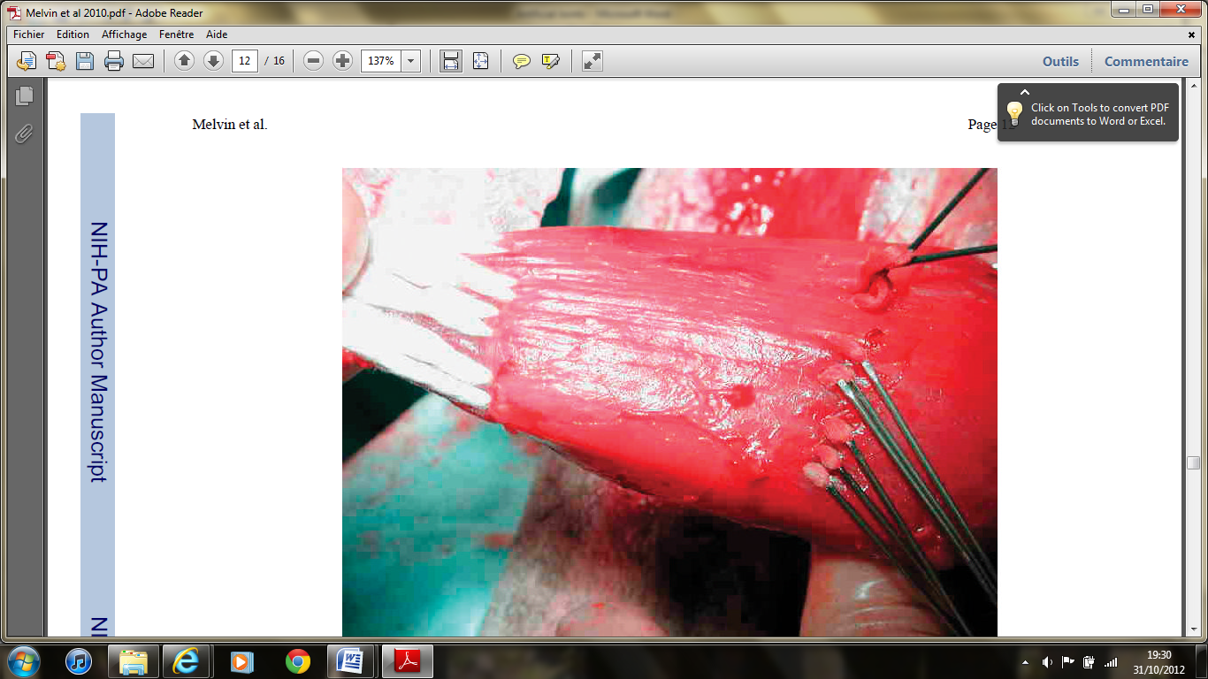

**Figure 7:** Artificial tendon. Artificial tendon synthetised by Melvin et al, made from polyester fibers (Melvin et al, 2010).

Melvin et al, describe a method of designing the artificial tendon in a long process detailed in their article published in 2010 (Melvin et al, 2010). The resultant beam is << OrthoCoupler >> made ​​of a few thousand fibers of polyethylene terephthalate (Fig 7). The red part is similar to a muscle, and the white part a tendon.

Remark:

The problem of the joint must be viewed in two ways, which are children bones and adult bones. If one considers that the joint is proportional to the size of the bone, it must be recalled hat for children, bones had not completed their growth in both length and width. The device must then be conducive to the long-term cellular activity. For adults, this is not the case, so we can fix it in an invariable size.

Another detail which must be taken into account is how the ligament or tendon has deteriorated: a genetic problem or an accident. In the case of o genetic problem, the approach must be done with the least possible biological material. The reason is because the goal of using biological material recognition, and long-term degradation of equipment replace the material created by these same cells. So we must use purely synthetic material, given that the problem is internal signaling unresponsive. If it is the result of an accident, it may well incorporate biological material for the long term, the fabric returns to its original state if nothing had happened.

Note also that the most important element dealing with movement is the potential action generated by the nerves at skeletal muscles. As the movement is very well attached to the bone, it results to a spatial displacement of the bone, noting that the bone itself is not controlled by the brain is the physical support for the implementation of its muscle stretching movements and contraction. In sum, it seems much easier to design an artificial ligament, compared with an artificial tendon, as we can see in the literature, because the ligament connects two very stable units of the same property, while the tendon connects two units of different properties, acknowledging that the muscle phase change frequently (contracts and relaxes). It is easier to insert a device into a bone rather than muscle.

**Product description**

Nature of the product

The device is an artificial joint designed according to different variables based on the case of the problem. There is the artificial ligament, the artificial tendon, and join spigots caused by cancer or natural origin. In fact, it is not possible to design a specific joint that will solve all problems. By definition, artificial joint implant is designed to attach two bones together, or a muscle to a bone, or restore a fractured bone.

Structure and Applications

1. Case of a broken ligament following an accident in adults.

To synthesize the join, it must take into account the elastic modulus (or tensile modulus) of Young by fear that it breaks. It is the constant which connects the compression stress to account for the deformation of a material. Should we therefore create the conditions to achieve the same resistance force as joint natural?

1. Case of the broken ligament following an accident in children.

Same with adult.

1. Case of problems such as osteoarthritis in adults (natural).

The Gold standard (Fig 4) using the "pure Titanium" is shown here, since the origin is purely natural. However, an amendment will be made ​​that will allow the joint in both axes at the shoulder, wrist, heel, and thumb.

1. Cases of natural problems affecting the ligament in children

A prosthesis polymer 3D

The polymer prosthesis that uses the principle c) but replace the metal with a polymer already used in the substitution of the ligament (ie: Polyethylene terephthalate, Polyhydroxyesters, Chitosan / Polyester). The material will be designed so that its Young's modulus is > or = Young's modulus of the cartilage. The idea of ​​elasticity is to accommodate the growth of the bone of the child over time. The material will stretch with the growth of the bone.

1. Case of tendon, usually accidental

If the tendon requires a flexible and highly elastic, a polymer should be used as beam << OrthoCoupler >> synthesized by *Melvin et al.* (Fig 7). To connect muscles and bones, we will just use floss commonly used as sewing thread in surgery.

1. Case of a gap in the bones or a cancer that two bones are too distinct to be joined.

3D support transparent plastic is synthesized from a computer simulation by simulating the area disconnected. The dough will be cast in bone solidifying support 3D rigid transparent plastic, once dried, the material will be removed.

Schematic of the principle

1. Case of a broken ligament following an accident in adults.

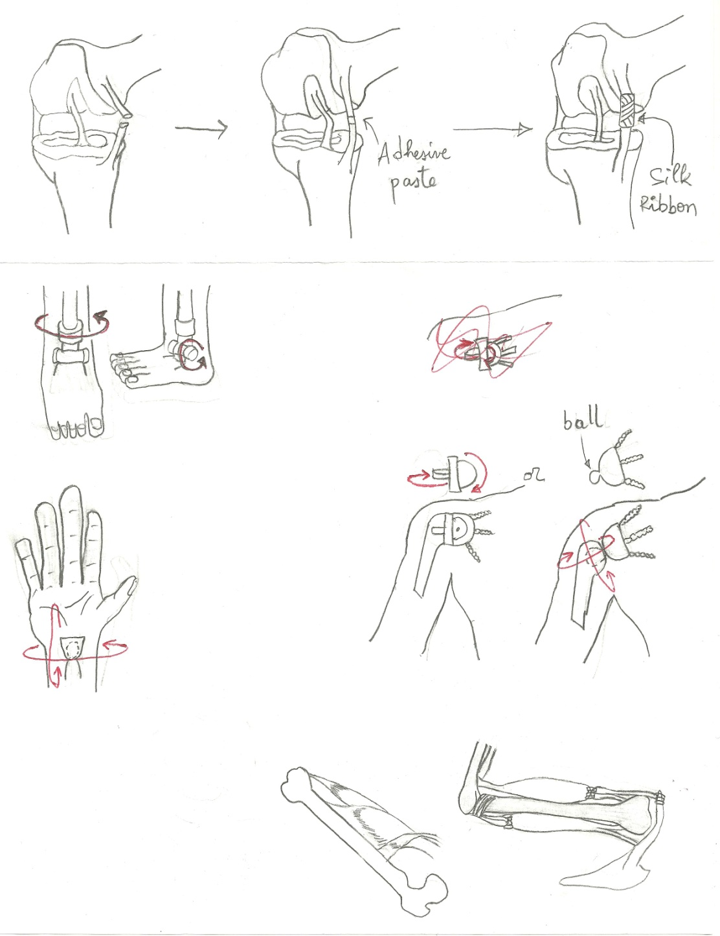

c) Case of problems such as osteoarthritis in adults (natural).

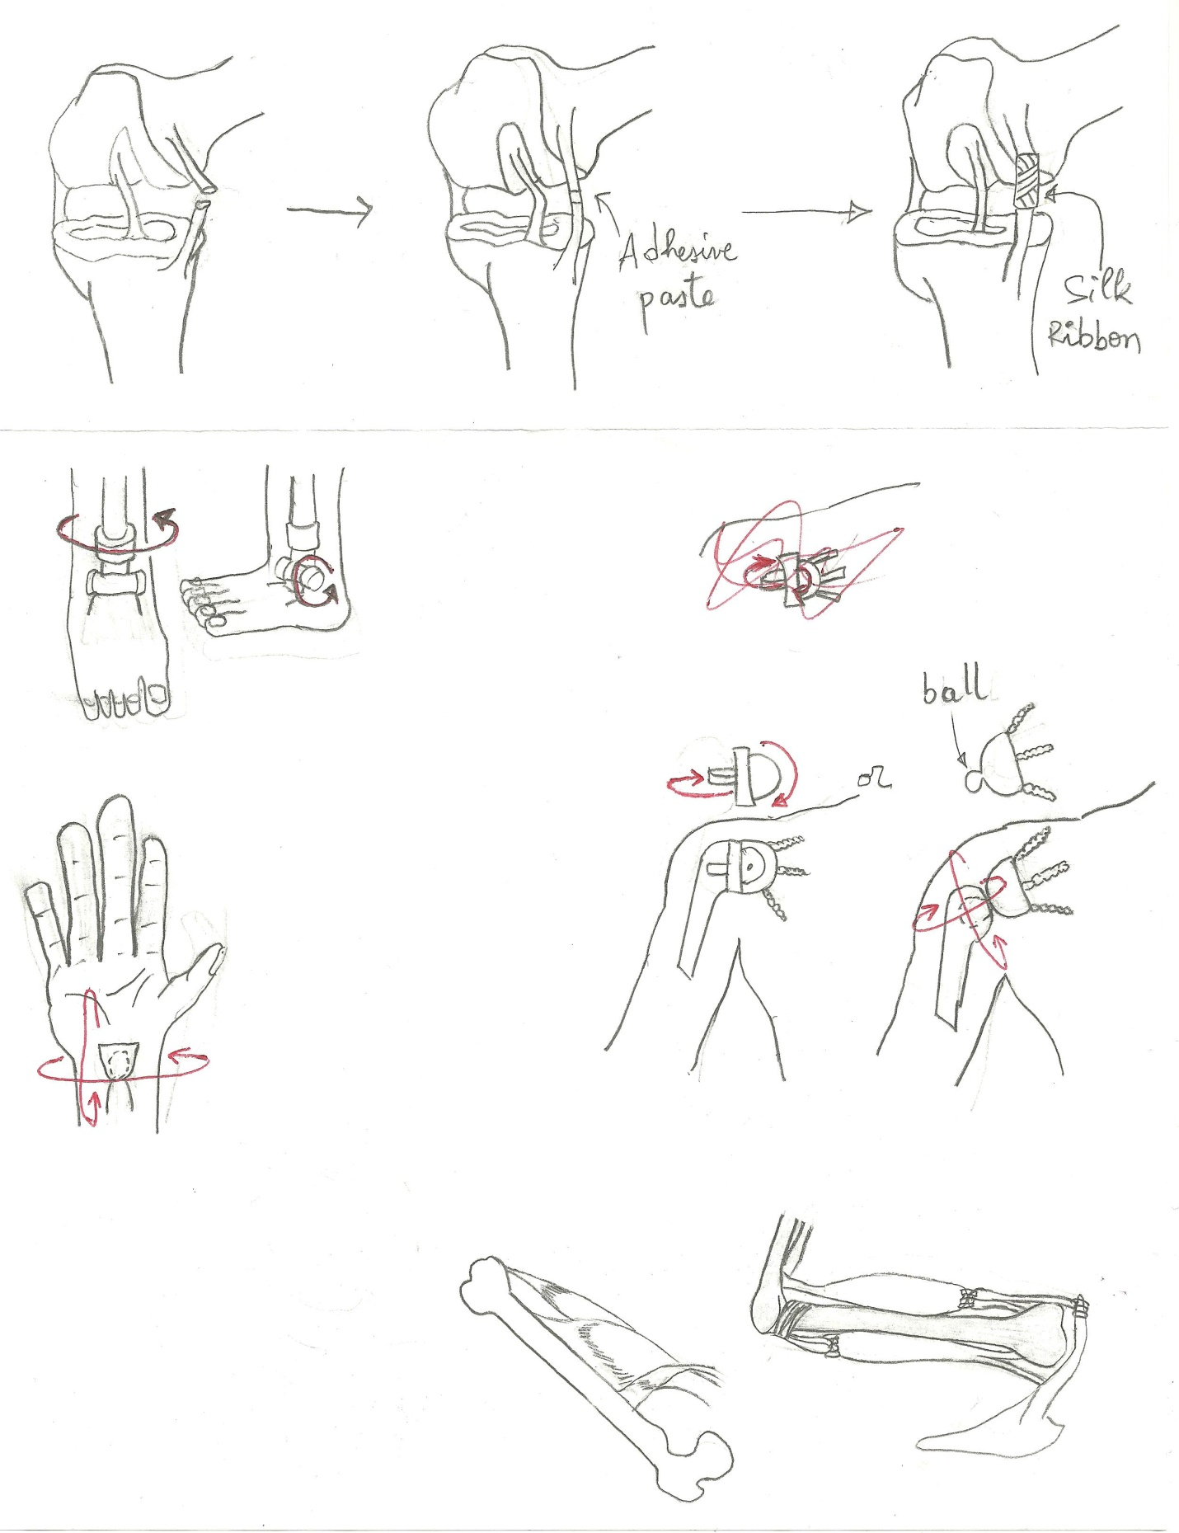 

d) Case of problems affecting the natural ligament in children



e) Case of tendon, usually accidental

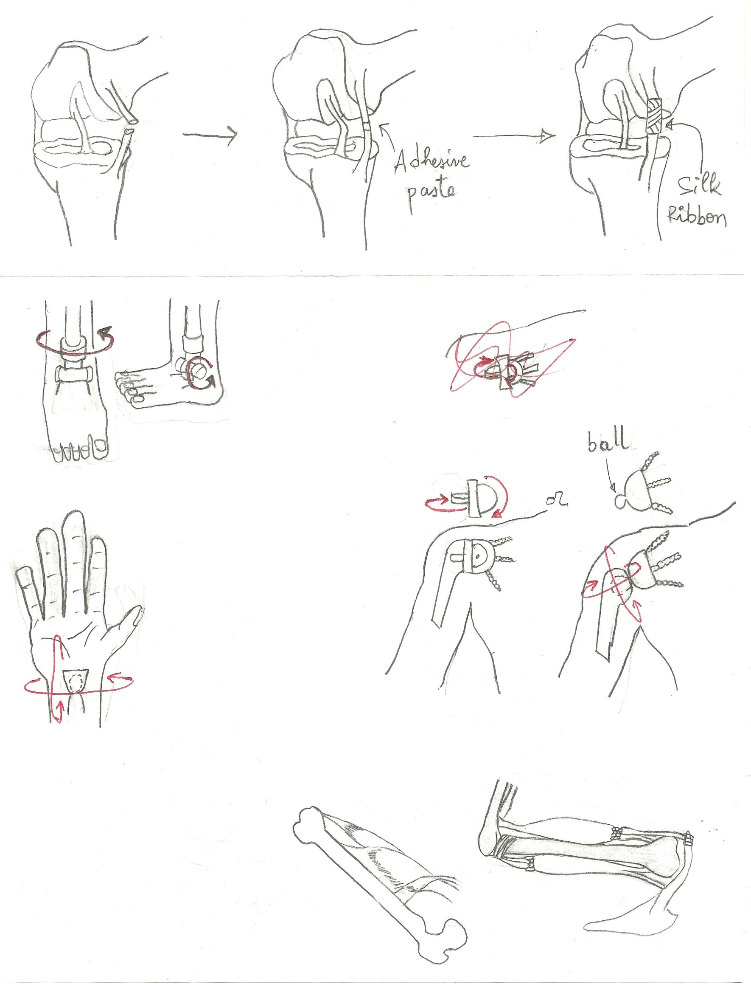

silk

orthocoupler

silk

Silk

Silk

orthocoupler

f) Case of a falsetto in bones or a cancer where two bones are too distinct to be joined



Fixing Support on the gap

drying

Huge Gap

Support 3D

Potential application to new and emerging technologies in the future

Work is carried out for many years that led to the design of polymers mentioned above. These polymers have already contributed to the design of artificial skin. The beam << OrthoCoupler >> synthesized by Melvin et al. can be very useful in the design of muscles artificers. It should add the parameter sensitive and connectivity to nerve cells. In addition, the use of bone pate in the future could be generalized to tendons, muscles and cartilages as the initial dosage is in the preparation of the dough. We take into account the fact that the bone is mainly carbonate hydroxyapatite ; tendons and cartilages are made of collagen and muscle actin and myosin.

**Results**

These are case-by-case basis in this project. It is expected that the solidifying paste adheres well to the cartilage structure as it does for the bone tissue, which is biocompatible. Both can be used in all tissues containing fine amounts of hydroxyapatite. The use of "pure titanium" is already clinical evidence to date, but the new amendment provides more freedom of movement for people who use it. We will see a clear difference in bone growth of a child using the prosthesis relative to the polymer by using the metal prosthesis.

The beam << OrthoCoupler >> synthesized by Melvin et al. might have some problems or fixing long-term compatibility, both in muscle and bone tissue, because this is a very recent method.

**Discussion**

Any process of implementing a biomaterial must consider four criteria, which are biocompatibility, osteoconductivity, porosity and mechanical compatibility (Venkatesan and Kim, 2010). This is the case because the body response to a device depends on properties of the latter, such as composition, degradation rate, morphology, porosity (Morais et al, 2010). There are many ways to avoid a negative response against a foreign biomaterial, anti-inflammatory medication. First biocompatibility is related to the degree of interaction with the biomaterial tissue host, and secondly, the production of materials with polymers is commonly found in nature. This offers the advantage of being very similar to biological macromolecules. Thus, it is more likely that the biological environment recognizes and integrates its metabolism (Morais et al, 2010). In this sense, tissue engineering strategy involves the use of biodegradable and biocompatible biomaterials with adequate structural and mechanical properties to mimic the organization of the native tissue (Yilgor et al, 2012).

Scaffolds are important components of tissue engineering strategy as they define the ultimate shape of the construct while providing the required mechanical strength during regeneration and proper cell attachment sites (Yilgor et al, 2012). There are alternate views on the ideal materials, the structure and composition of it. For ligament tissue engineering, it is generally believed that a scaffold that allows immediate load bearing and degrades at a comparable rate with the tissue regeneration would form the ideal engineered ligament (Yilgor et al, 2012). The ethical justification for this is that natural cycle is the use and recycling of materials. Principle of biodegradability is to bring the product to its original state is well respected.

Unlike collagen, which adopts a helical conformation α, silk adopts a conformation mainly β sheets, so it can therefore be used to replace collagen as the collagen binding. Note that the idea works because polymers have a linear structure, similar to a helix α.

An alternative to all this is the final cell culture, cells would take small intestine submucosa (SIS). The problem of SIS from the intestine of the pig will be purely Ethics. Some religions do not eat pork so it would be hard to believe that people accept this religion in their body tissues made ​​entirely of pork. To resolve this issue, we can use a different animal pig intestinal similar properties, otherwise collect directly from intestinal tissue of the patient. Here, we adapt the extracellular ECM under the conditions desired end. Cells will be subject to the same environmental conditions of final cell, voltage, the rate of oxygen, specific growth factor, and pH. Within a short time, the resident cells responds to environmental cues and secretes molecules appropriate to accommodate new and changing environments, Malthus Modifying the Existing ECM. Conditions differ slightly if you want to get lost, versus tendon, ligament versus. However, limitation of this is that very little are known about cellular differentiation that may lead to such a feat.

**Conclusions and Recommendations**

The design of artificial joints is done according to a base problem. Among the many solutions that already exist, only Titanium and transplants are already proven, with some limitations in transplants. Variable added to joints and synthesis of 3D polymers as present in Young's modulus of substituted materials are in fact new possibilities in the future that could improve the quality of joints.

As a recommendation, we must go on a case-by-case basis; distinguish the origin of the problem (natural or accidental), and distinguish the age of the patient to minimize any interference with the material growth of the latter.

**References**

1. Elia Beniash. **Biominerals- hierarchical nanocomposites: the example of bone**. *Wiley Interdiscip Rev Nanomed Nanobiotechnol*. 2011 ; 3(1): 47–69. doi:10.1002/wnan.105.
2. Jayachandran Venkatesan and Se-Kwon Kim. **Chitosan Composites for Bone Tissue Engineering**—**An Overview**. *Mar. Drugs* 2010, *8*, 2252-2266; doi:10.3390/md8082252.
3. S. Weiner and H. D. Wagner. **The material bone : structure-mechanical function relations**. *Annu. Rev. Mater. Sci. 1998. 28:271–98*
4. Frederic Shapiro. **Bone development and its relation to fracture repair. The role of mesenchymal osteoblasts and surface osteoblasts.** *European Cells and Materials* 2008 Vol. 152008 (pages 53-76)
5. Jamshid Khoshnoodi , Jean-Philippe Cartailler , Keith Alvares, Arthur Veis, and Billy G. Hudson **Molecular Recognition in the Assembly of Collagens: Terminal Noncollagenous Domains Are Key Recognition Modules in the Formation of Triple Helical Protomers** *the journal of biological chemistry* VOL. 281, NO. 50, pp. 38117–38121, December 15, 2006
6. N. H. de Leeuw. **Computer simulations of structures and properties of the biomaterial Hydroxyapatite**. *Journal of Materials Chemistry*. 2010 March
7. William Johnson. **Initiation à la Chimie organique**. *De Boeck Supérieur*, 2002-12-04 - 784 pages.
8. [Reginald H. Garrett](http://www.google.ca/search?hl=fr&tbo=p&tbm=bks&q=inauthor:%22Reginald+H.+Garrett%22), [Charles M. Grisham](http://www.google.ca/search?hl=fr&tbo=p&tbm=bks&q=inauthor:%22Charles+M.+Grisham%22). **Biochimie.** *De Boeck Supérieur*, 2000 - 1292 pages.
9. [Li WJ](http://www.ncbi.nlm.nih.gov/pubmed?term=Li%20WJ%5BAuthor%5D&cauthor=true&cauthor_uid=16765878), [Cooper JA Jr](http://www.ncbi.nlm.nih.gov/pubmed?term=Cooper%20JA%20Jr%5BAuthor%5D&cauthor=true&cauthor_uid=16765878), [Mauck RL](http://www.ncbi.nlm.nih.gov/pubmed?term=Mauck%20RL%5BAuthor%5D&cauthor=true&cauthor_uid=16765878), [Tuan RS](http://www.ncbi.nlm.nih.gov/pubmed?term=Tuan%20RS%5BAuthor%5D&cauthor=true&cauthor_uid=16765878). **Fabrication and characterization of six electrospun poly(alpha-hydroxy ester)-based fibrous scaffolds for tissue engineering applications**. [*Acta Biomater.*](http://www.ncbi.nlm.nih.gov/pubmed/16765878) 2006 Jul ; 2(4):377-85. Epub 2006 May 6.
10. [Struewer J](http://www.ncbi.nlm.nih.gov/pubmed?term=Struewer%20J%5BAuthor%5D&cauthor=true&cauthor_uid=22976592), [Ziring E](http://www.ncbi.nlm.nih.gov/pubmed?term=Ziring%20E%5BAuthor%5D&cauthor=true&cauthor_uid=22976592), [Ishaque B](http://www.ncbi.nlm.nih.gov/pubmed?term=Ishaque%20B%5BAuthor%5D&cauthor=true&cauthor_uid=22976592), [Efe T](http://www.ncbi.nlm.nih.gov/pubmed?term=Efe%20T%5BAuthor%5D&cauthor=true&cauthor_uid=22976592), [Schwarting T](http://www.ncbi.nlm.nih.gov/pubmed?term=Schwarting%20T%5BAuthor%5D&cauthor=true&cauthor_uid=22976592), [Buecking B](http://www.ncbi.nlm.nih.gov/pubmed?term=Buecking%20B%5BAuthor%5D&cauthor=true&cauthor_uid=22976592), [Schüttler KF](http://www.ncbi.nlm.nih.gov/pubmed?term=Sch%C3%BCttler%20KF%5BAuthor%5D&cauthor=true&cauthor_uid=22976592), [Ruchholtz S](http://www.ncbi.nlm.nih.gov/pubmed?term=Ruchholtz%20S%5BAuthor%5D&cauthor=true&cauthor_uid=22976592), [Frangen TM](http://www.ncbi.nlm.nih.gov/pubmed?term=Frangen%20TM%5BAuthor%5D&cauthor=true&cauthor_uid=22976592). **Second-look arthroscopic findings and clinical results after polyethylene terephthalate augmented anterior cruciate ligament reconstruction**. [*Int Orthop*.](http://www.ncbi.nlm.nih.gov/pubmed/22976592) 2012 Sep 14.
11. G. vunjak-Novakovic, gregory Altman, rebecca Horan, and david l. Kaplan. **Tissue engineering of ligaments.** *annu. rev. biomed. eng*. 2004. 6:131–56.
12. Christian Egloff, Thomas Hügle, Victor Valderrabano. **Biomechanics and pathomechanisms of osteoarthritis**. *Swiss Med Wkly*. 2012;142:w13583.
13. Guy M. Genin, Alistair Kent, Victor Birman, Brigitte Wopenka, Jill D. Pasteris, Pablo J. Marquez, and Stavros Thomopoulos. **Functional Grading of Mineral and Collagen in the Attachment of Tendon to Bone**. *Biophysical Journal* Volume 97 August 2009 976–985.
14. Caglar Yilgor, Pinar Yilgor Huri, and Gazi Huri**. Tissue Engineering Strategies in Ligament Regeneration.** *Stem Cells International* Volume 2012, Article ID 374676, 9 pages doi:10.1155/2012/374676.
15. Durgesh G. Nagarkatti, MBBS, Brian P. McKeon, MD, Brian S. Donahue, MD, and John P. Fulkerson, MD. **Mechanical Evaluation of a Soft Tissue Interference Screw in Free Tendon Anterior Cruciate Ligament Graft Fixation.** The american journal of sports medicine, 2001 Vol. 29, No. 1.
16. Manuela Gomes, Helena Azevedo, Patrıcia Malafaya, Simone Silva, Joaquim Oliveira, Gabriela Silva, Rui Sousa Joa˜o Mano and Rui Reis. **Natural Polymers in Tissue Engineering Applications**. 2008 Elsevier.
17. Michael Plecko, Christine Sievert, Daniel Andermatt, Robert Frigg, Peter Kronen, Karina Klein, Stefan Stübinger, Katja Nuss, Alexander Bürki, Stephen Ferguson, Ulrich Stoeckle and Brigitte von Rechenberg. **Osseointegration and biocompatibility of different metal implants - a comparative experimental investigation in sheep**. *BMC Musculoskeletal Disorders* 2012, 13:32.
18. Stephen F. Badylak. **Extracellular Matrix As a Scaffold for Tissue Engineering in Veterinary Medicine: Applications to Soft Tissue Healing**. *Elsevier* 2004.
19. Jacqueline M. Morais,1 Fotios Papadimitrakopoulos,2 and Diane J. Burgess 1,3. **Biomaterials/Tissue Interactions: Possible Solutions to Overcome Foreign Body Response**. *The AAPS Journal*, June 2010 Vol. 12, No. 2, (# 2010) DOI: 10.1208/s12248-010-9175-3.
20. [Kasaj A](http://www.ncbi.nlm.nih.gov/pubmed?term=Kasaj%20A%5BAuthor%5D&cauthor=true&cauthor_uid=18818463), [Willershausen B](http://www.ncbi.nlm.nih.gov/pubmed?term=Willershausen%20B%5BAuthor%5D&cauthor=true&cauthor_uid=18818463), [Reichert C](http://www.ncbi.nlm.nih.gov/pubmed?term=Reichert%20C%5BAuthor%5D&cauthor=true&cauthor_uid=18818463), [Röhrig B](http://www.ncbi.nlm.nih.gov/pubmed?term=R%C3%B6hrig%20B%5BAuthor%5D&cauthor=true&cauthor_uid=18818463), [Smeets R](http://www.ncbi.nlm.nih.gov/pubmed?term=Smeets%20R%5BAuthor%5D&cauthor=true&cauthor_uid=18818463), [Schmidt M](http://www.ncbi.nlm.nih.gov/pubmed?term=Schmidt%20M%5BAuthor%5D&cauthor=true&cauthor_uid=18818463). **Ability of nanocrystalline hydroxyapatite paste to promote human periodontal ligament cell proliferation**. [*J Oral Sci.*](http://www.ncbi.nlm.nih.gov/pubmed/18818463) 2008 Sep;50(3):279-85.
21. Alan Melvin, Alan Litsky, Sc.D, Joel Mayerson, , David Witte, David Melvin,and Natalia Juncosa-Melvin, Ph.D. **An Artificial Tendon with Durable Muscle Interface**. *J Orthop Res*. 2010 February ; 28(2): 218–224. doi:10.1002/jor.20971.
22. [www.chemistryland.com/ElementarySchool/BuildingBlocks/CHM130BBquiz.htm](http://www.chemistryland.com/ElementarySchool/BuildingBlocks/CHM130BBquiz.htm)
23. genouetsport.fr/Anatomie-GENOU-Ligament-